IFS 354: GROUP 8 ASSIGNMENT

GROUP MEMBERS:

3974946 – DARREN MORKEL

3973308 – SIYANELA MZIBA

3703325 – AGAPE TSHIGOMANA

3972158 – ANDISIWE NKUKWANA

DUE DATE: 4 JULY 2021 – 11:59 PM

MARKS: 100

|  |  |  |  |
| --- | --- | --- | --- |
| **Name & Surname** | **Student Number** | **Contribution** | **Signature** |
| Darren Morkel (Project Manager) | 3974946 | 100% | IMG-3279.jpg |
| Siyanela Mziba | 3973308 | 100% | WhatsApp Image 2021-07-03 at 10.57.19 AM.jpeg |
| Agape Tshigomana | 3703325 | 100% | WhatsApp Image 2021-07-03 at 10.27.12 AM.jpeg |
| Andisiwe Nkukwana | 3972158 | 100% | WhatsApp Image 2021-07-03 at 9.06.48 AM.jpeg |

**Brief overview of the project:**

An up-and-coming e-commerce venture that has crept its way into a niche position, given the current local and worldwide conditions - can be seen in that of grocery and food delivery services. The need for digitalisation amongst businesses has grown enormously over the last decade and is continuing to do so at a steady rate. Hence, the incorporation of these technologies can be used to an organisation’s greatest benefit. Furthermore, with the effects of COVID-19 still prevalent, there are fewer customers that are willing to risk their health and well-being when looking to do grocery shopping. As a result, the need for an organisation that specializes in grocery delivery services from multiple stores on a single platform can be seen as a niche in today’s climate. This is because on one hand it offers customers greater satisfaction, while on the other hand it will also lead to potential employment opportunities. Payment mechanisms involved in this business model will include that of online payment systems and cash-on-delivery. Customers will be able to handle all orders, payments and debts electronically via the business’s website/application. For the purposes of this project and for future reference, the organisation name will be called GroceryFrenzy.

**Justification of the selected agile procedure:**

Approaches that are frequent or repetitive in nature are frequently used in software development projects because it encourages speed and responsiveness. One of the major objectives of an agile approach is to reach project milestones during the process instead of only at the end. Scrum and Kanban are two of the most commonly used agile procedures in today’s market.

Therefore, the agile methodology used for this project will be that of the Scrum approach. Scrum is a subcomponent of agile procedure when it comes to project management. It is a cost-effective activity structure for agile development, and the most widely-used one. “Cost-effective” implies that the overall costs incurred will be kept to a minimum, while simultaneously maximizing the amount of production time available. “Activity structure” implies that a certain sequence of activities need to be followed in order for the project to maintain consistency and run in an incremental fashion throughout its duration. For example, resource gathering needs to happen before the erection of walls can be completed in the construction of a mall.

The Scrum process is renowned amongst other agile processes by specific notions and application. Scrum is most commonly used to supervise complicated software and product development, using repetitive and “step-by-step” practices. Scrum greatly increases productivity and reduces the time taken to gain benefits as opposed to classic “waterfall” procedures. Scrum processes allow companies to steadily adjust to rapidly-changing environments, and create a product that meets progressive organization goals. The main reason as to why we will be following the Scrum approach is because it will increase the overall quality of project deliverables, while allowing us to deal with change more effectively. It will also emphasize the creation of products and prototypes as opposed to planning and brainstorming. As a result, it will allow us to work more effectively within a time-constrained project environment.

**Website Wireframe:**

Main page (1st)

Text is brought down and faded in with animation, sits above the background picture

Links created for **Log In and Sign Up** pages

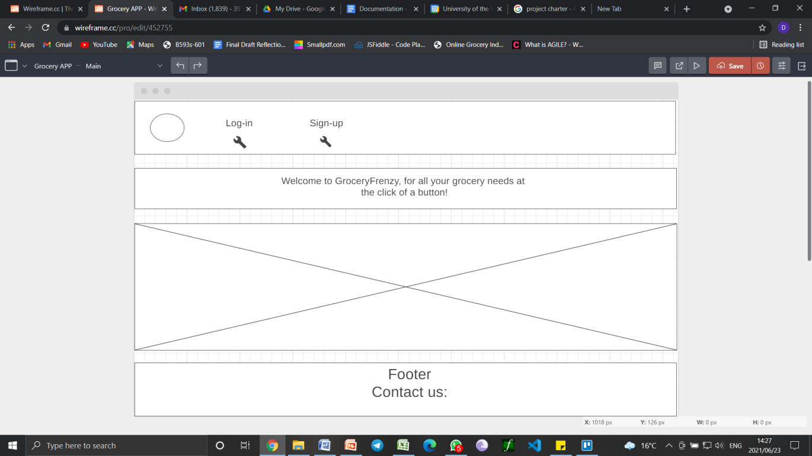

Second page:

Sign Up page.

Details: Username, Phone number, Password (dummy text needed to fill out the form)

**OK Button takes you to Log In page**

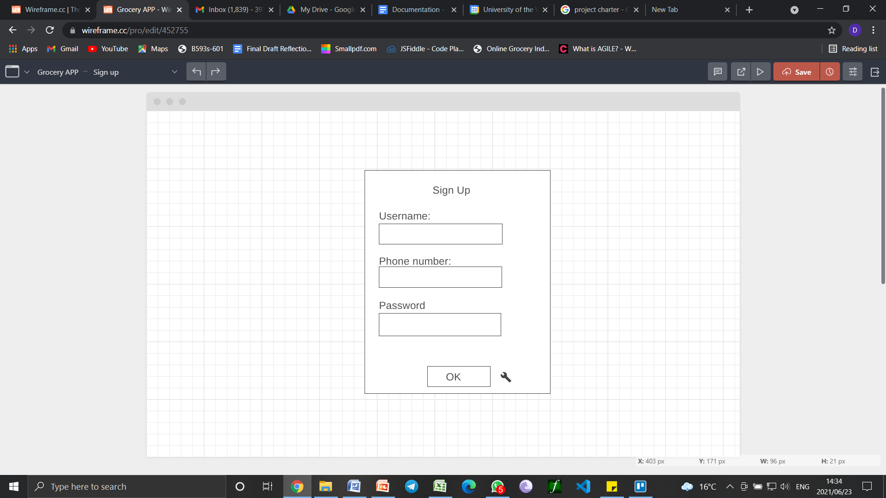

Third page:

Log In page.

**Submit button takes you to Home**

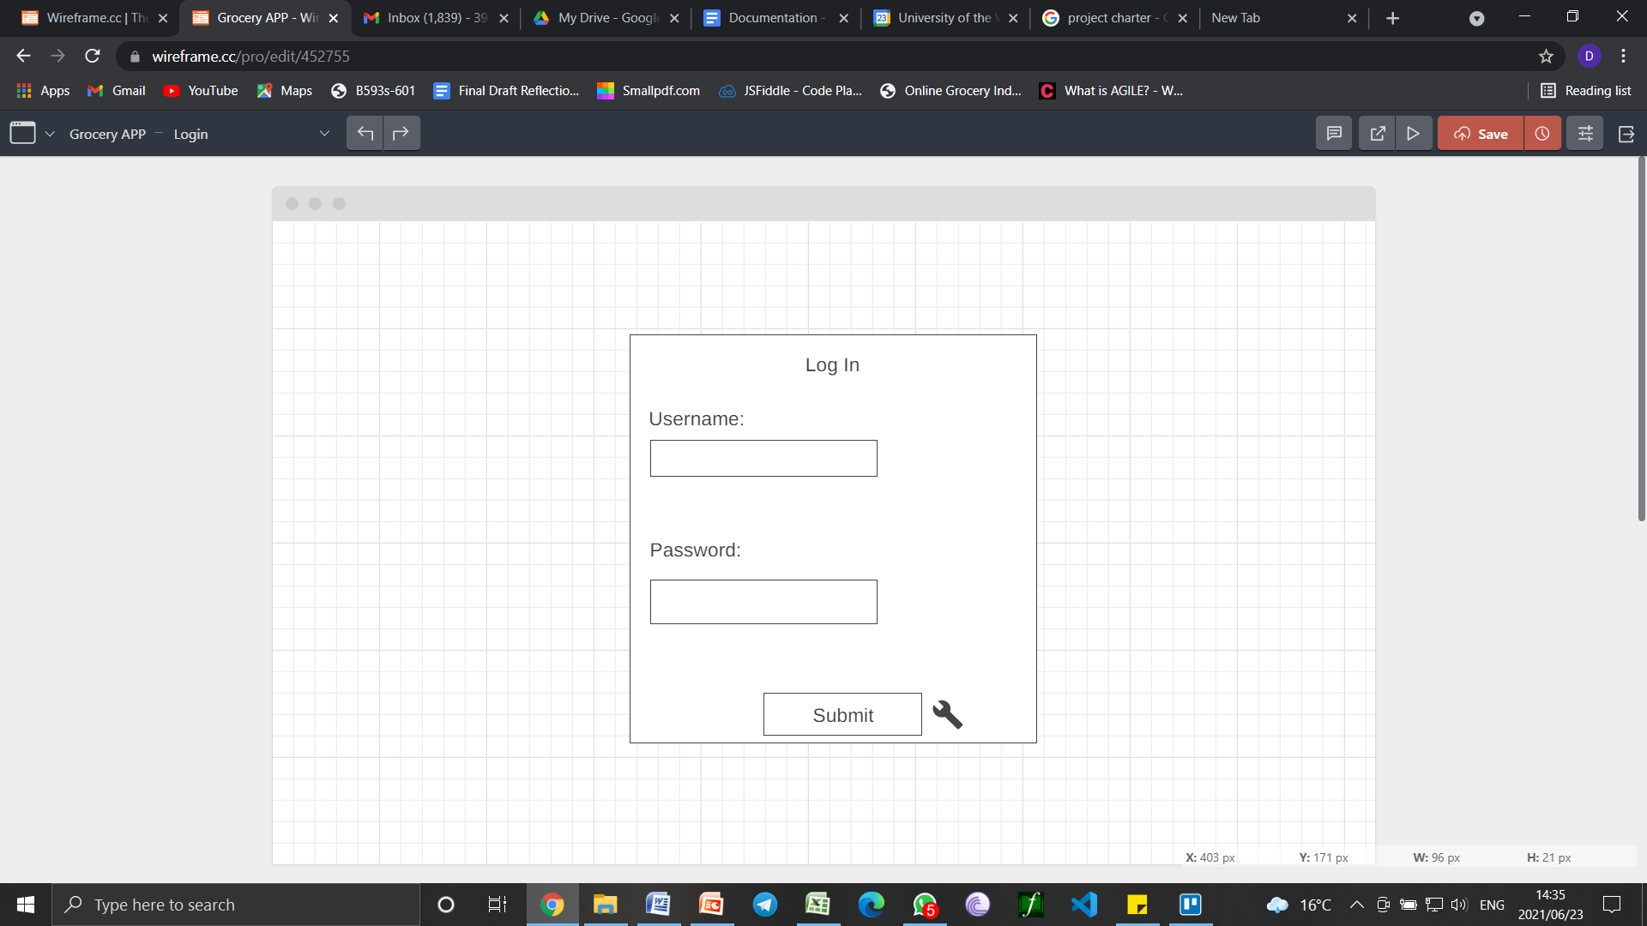

Fourth page:

Text is brought down and faded in with animation, sits above the background picture

Links created for **Home and Order**

Clicking on Order takes us to **order page**

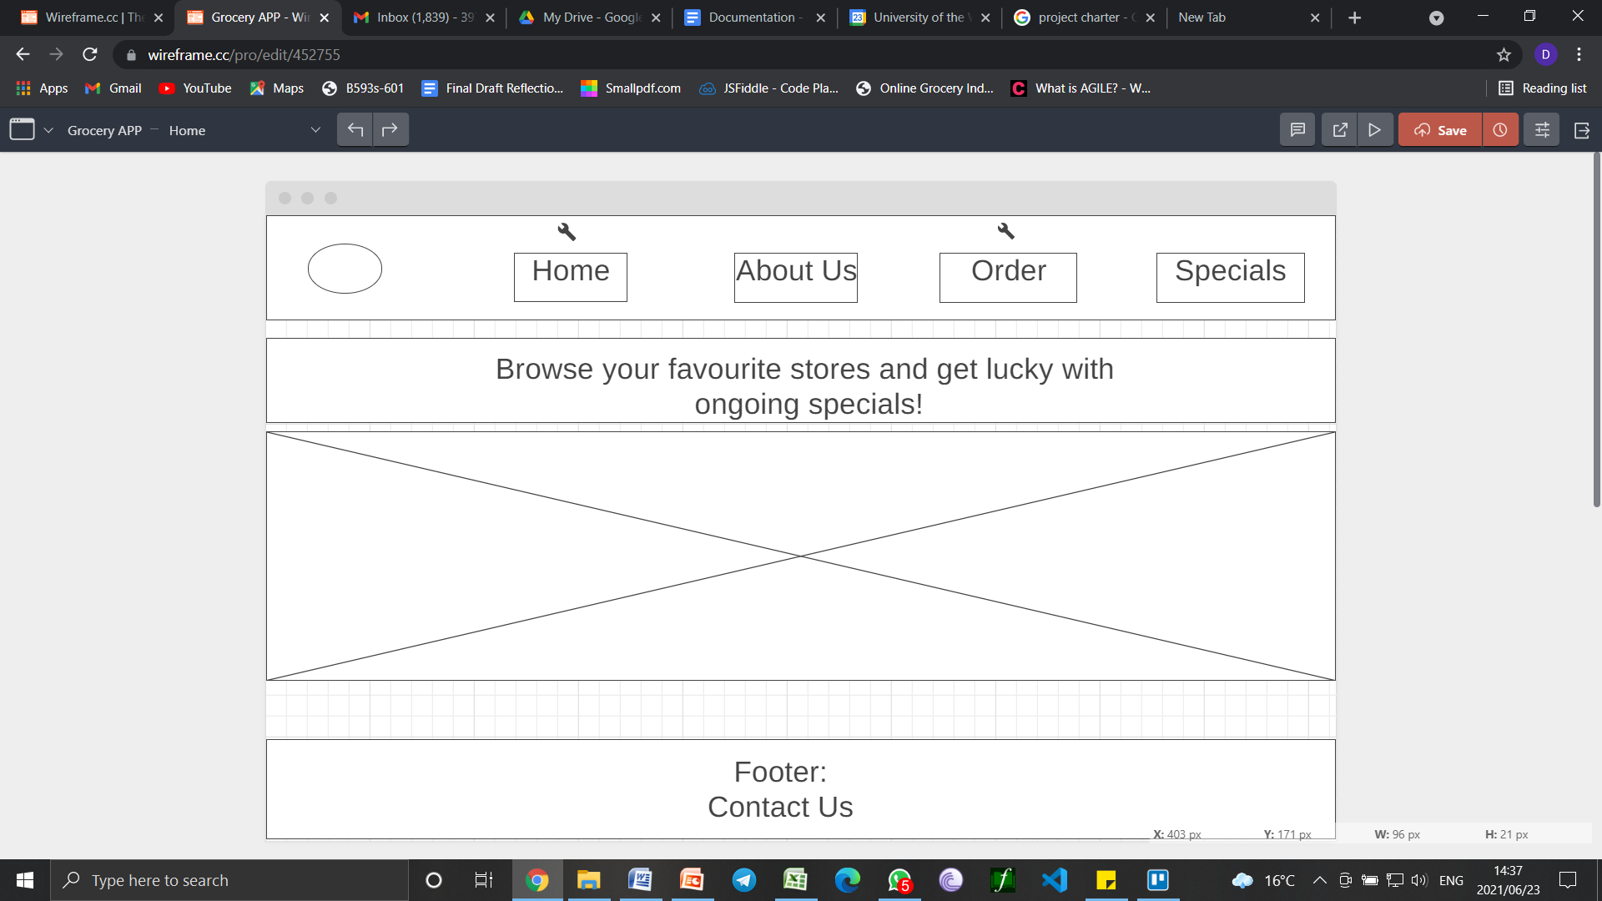

Fifth page:

Order page, Input fields for grocer, items and address of the user.

Link created for **Home and Payment details page (Button that says “Proceed to payment”)**

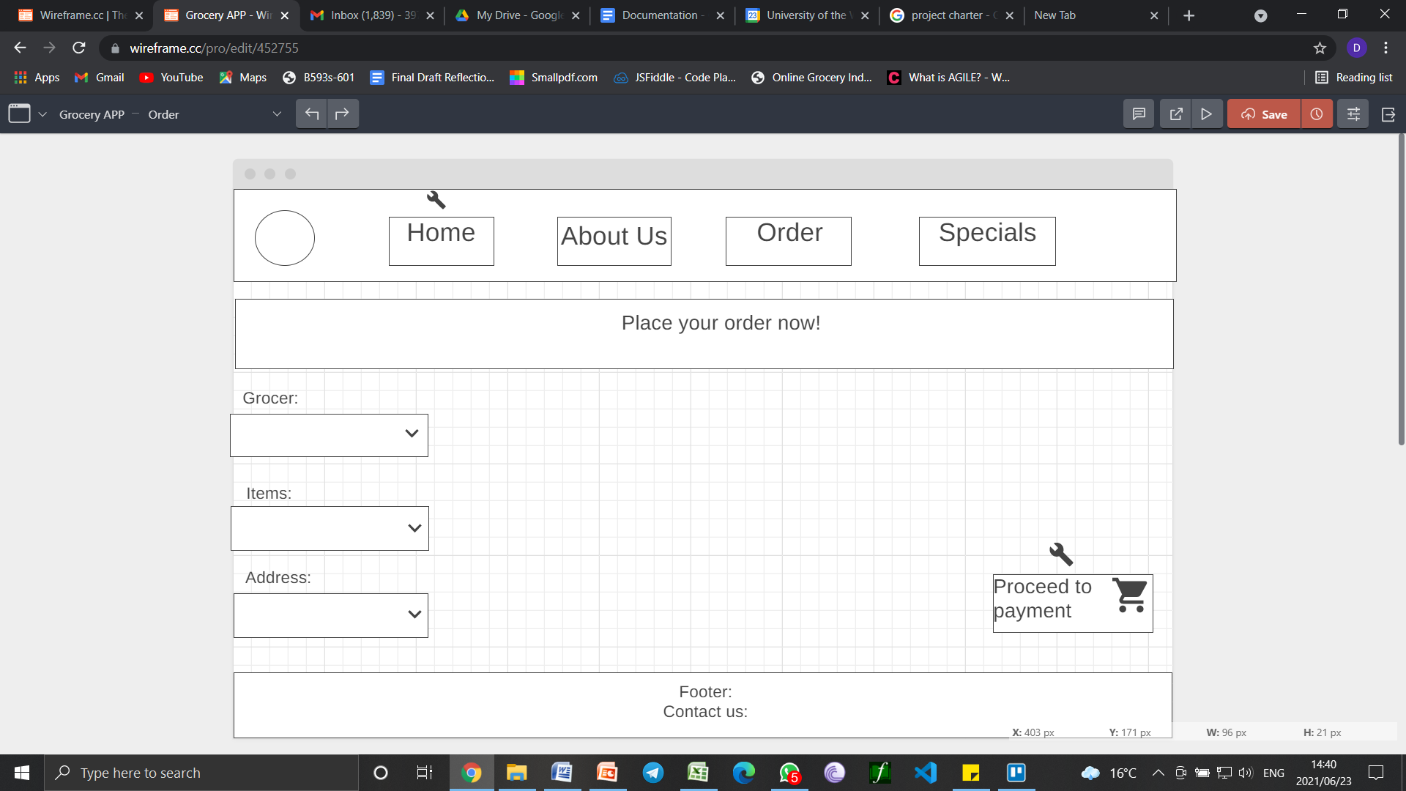

Sixth page:

Payment details page,, input fields created for carholder name, card number, mm/yy and cvv, check box that gives user option to save the card for future purchases

**Link created on “proceed to checkout” button, which takes user to checkout page**

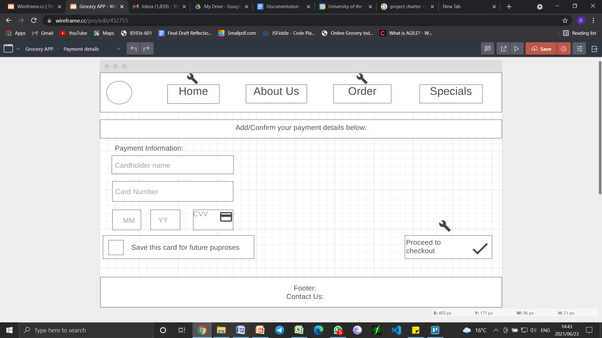

Seventh page:

Checkout page

Link created for **successful order** page on the “order & pay” button

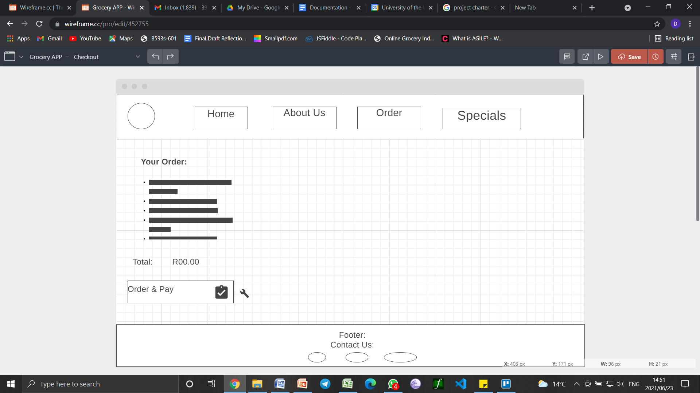

**User documentation:**

The proposed website for the grocery delivery application is built in the most simplistic way in nature. Javascript is limited due our lack of knowledge hereof and hence, our website only features one page with functioning Javascript, the **Login** page.

An important note: When logging into the website, the user needs to use the given credentials; **Username: Admin | Password: 1234.** Should the user leave the required fields blank, a Javascript function will alert the user to fill out the fields. Once the user fills out these fields with the required credentials stated above, Javascript will then redirect the user to the Home Page. From here, the website functions strictly with HTML and CSS. Hence, the only way of navigating further on through the website will be via the navigation bar as well as via the buttons on the “order” and “payment” forms.

CSS has been included to style the website as best we could, with further incorporation of animations as well. This was done to give the user a more appealing experience given the lack of our website’s overall functionality.

**Gantt chart:**

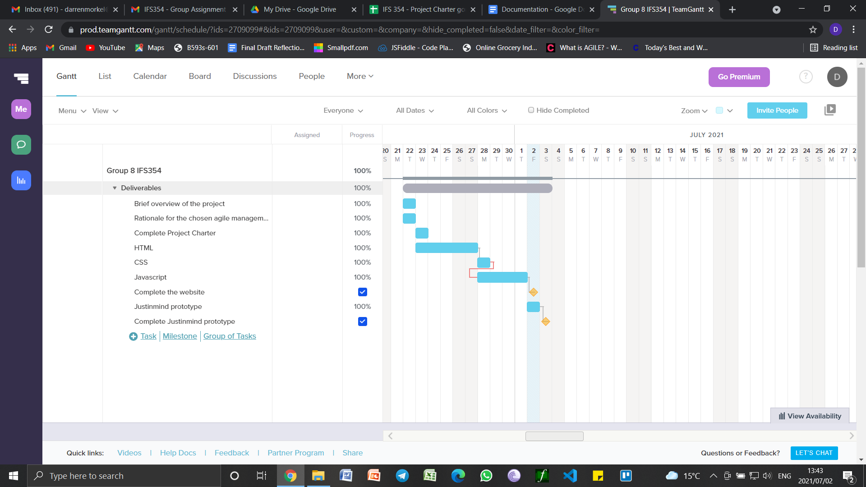

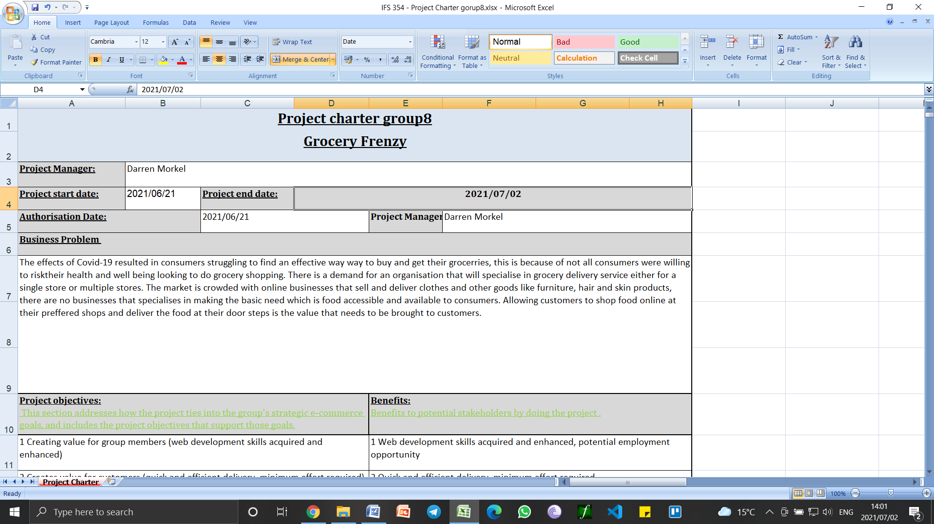

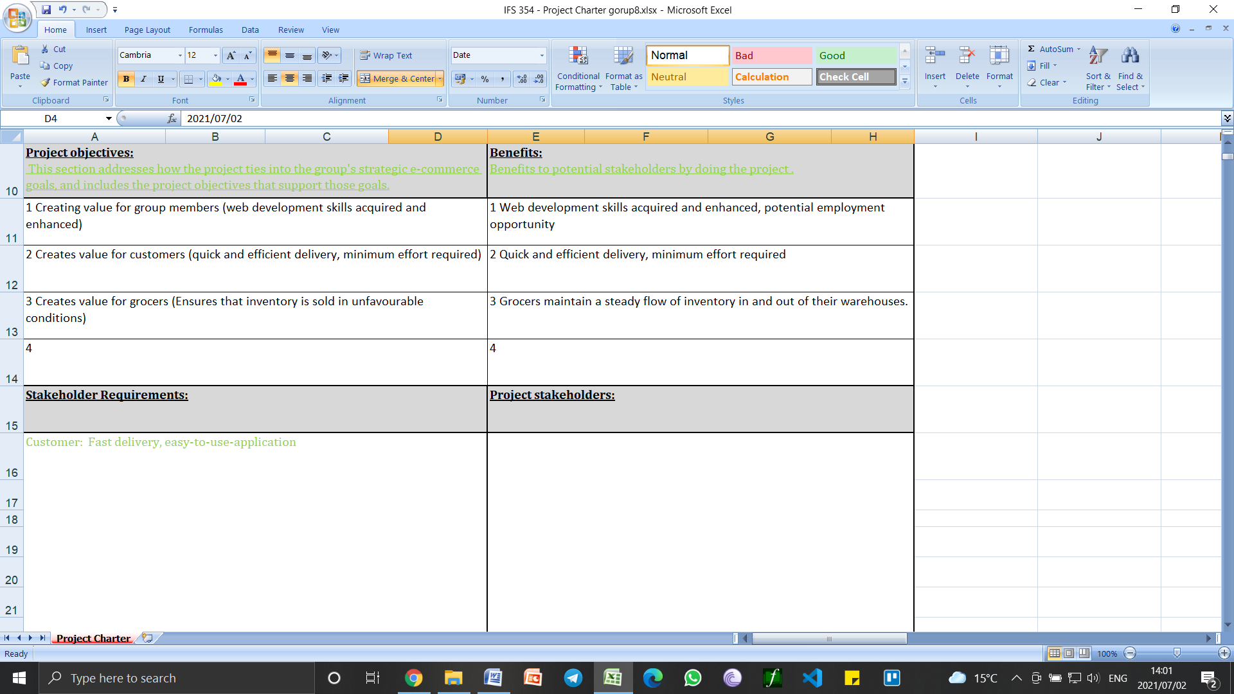

-Customer

-Project Team (Developers, project manager)

-Project sponsor

Customer: Fast and efficient delivery, easy-to-use- application

Project team: Hardware (computers) Information Systems expertise

Project sponsor: Funding

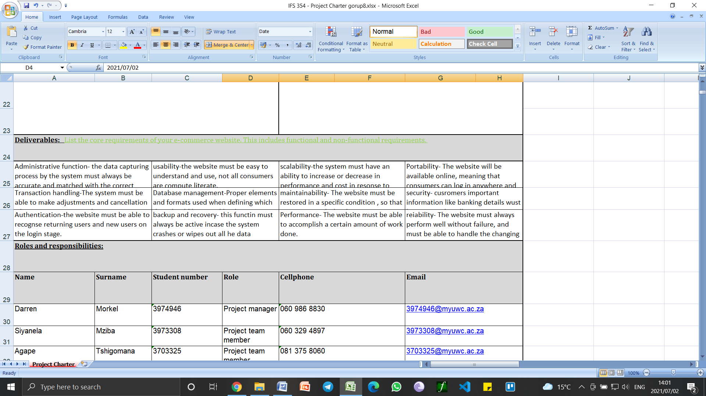

|  |  |  |  |  |  |
| --- | --- | --- | --- | --- | --- |
| Andisiwe | Nkukwana | 3972158 | Project team member | 061 433 9290 | 3972158@myuwc.ac.za |

